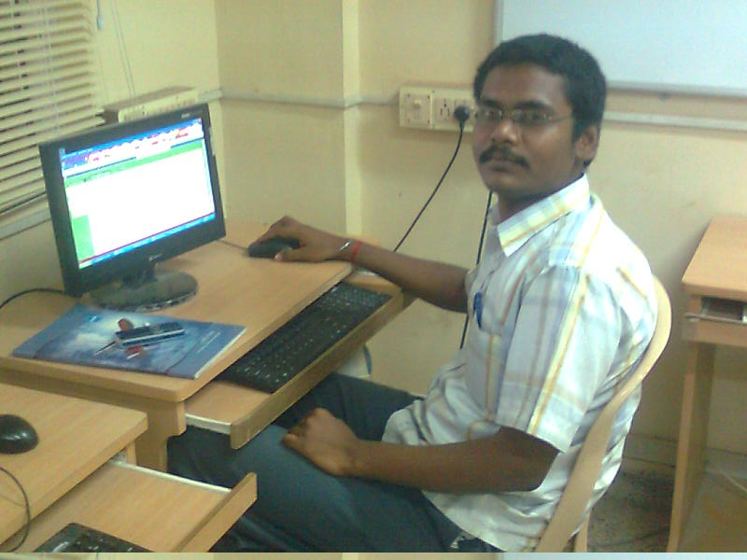

Naga vignesh selvaraj
Bio-informatics lab
nagavignesh@gmail.com
http://in.linkedin.com/in/vigneshns

Academic chronicle:

M.S (By Research) in Biotechnology at Anna University
B.Tech. in Industrial Biotechnology at Anna University

Research interests:
- Genetic network construction and analysis
- Statistics on micro array data
- High throughput screening techniques
- Molecular mechanisms in cancer
Previous works:
- Taxane Knowledge Base
- Screening of Effective natural taxane from TaxKB
- Computational approaches to enhance activity of Taxanes as antimitotic agent
- QSAR studies on taxanes activity in Multi Drug Resistant cancer cells
- Biomarker identification for non small lung cancer

Manuscripts under review:
“Screening of Effective Natural Taxanes from Taxane Knowledge Base (Tax KB)”
Nagavignesh Selvaraj, Kandavel Palani Kannan, Gopal Ramesh Kumar

“Computational approaches to enhance activity of Taxanes as antimitotic agent”
P.M.Sivakumar*, Nagavignesh Selvaraj and G.Ramesh Kumar, Mukesh Doble*

“Computational approaches to enhance Taxanes activity in Multidrug resistance cancer cells”

P.M.Sivakumar*, Nagavignesh Selvaraj and G.Ramesh Kumar, Mukesh Doble

Posters on international conferences:
- “Biomarker identification using Micro array data analysis for Non Lung cancer” at International Conference on “Open Source in Computer Aided Drug Design” Institute of Microbial Technology (IMTECH), Chandigargh during March 2009.

- “Taxane Knowledge Base (Tax KB)” at International Conference on Molecular Medicine“ Molmed-2009” Indian Institute of Technology Madras, Chennai during January 2009.

- “Biomarker identification for Lung cancer” at International Conference on Molecular Medicine“Molmed-2009” Indian Institute of Technology Madras, Chennai during January 2009.

- “Screening of Effective Taxane from TaxKB” at 77th Annual Meeting of the Society of Biological Chemists” Indian Institute of Technology Madras, Chennai during December 2008

- “Screening of Effective Taxane with Improved Anticancer Activity” at 12th International Conference on “The Interface of Chemistry-Biology in Biomedical Research” Birla Institute of Technology and Science, Pilani during February 2008

- “Open Source in Bioinformatics” at FossConf Chennai at AU-KBC Research Centre, M.I.T Campus, Anna University, Chrompet during February 2008

- “Functional genomics approach for augmentation of lovastatin productivity” at 48th Annual conference of Association of Microbiologists of India, IITM during December 2007.

- “Toxic effects of Aeglemarmelos on the growth of some pathogenic organism” and “Bacteriological analysis of three rain water ponds of Virudhunagar and Madurai district” at the National conference on Recent Trends in Microbial Biotechnology, conducted by SASTRA Deemed University, Thanjavur during march 2004.

